INTERNAL EVENT MARKETING STRATEGY
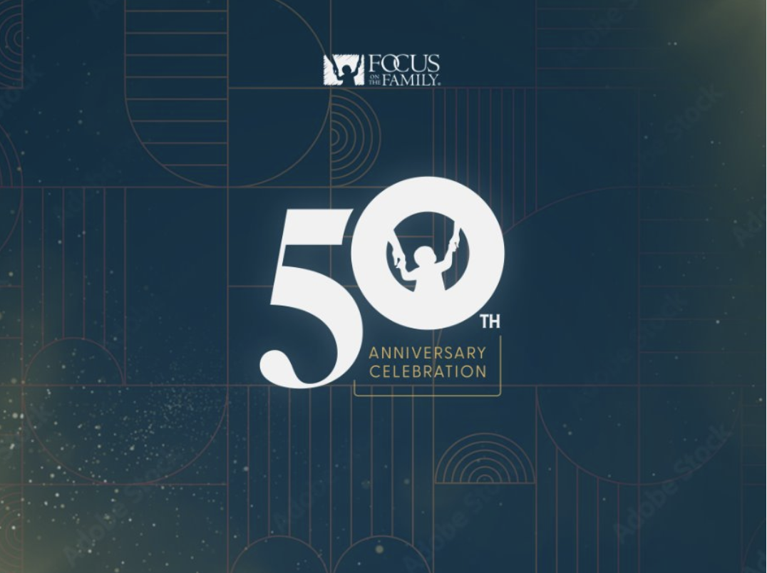
Focus on the Family
50th Anniversary Celebration
Event Marketing Strategy
July 29–31, 2027 | Colorado Springs
Working Plan | August 2026

EXECUTIVE SUMMARY

Event marketing strategy
The Focus on the Family 50th Anniversary Celebration is a three-day weekend in Colorado Springs designed to celebrate 50 years of ministry and invite families into a hopeful vision for the future. The marketing strategy is focused on selling the public Friday experience: an open-house-style day at Focus on the Family headquarters followed by the 50th Anniversary Concert at Ford Amphitheater. Ford Amphitheater is the concert venue; the Friday ticket should present the day and evening as one connected experience.
The primary marketing outcome is paid-event sellout. The lead offer is the complete weekend package, supported by a disciplined presale sequence and a controlled soft launch before the broader national rollout in early 2027. Individual-event inventory should open only after package sales reach a defined tipping point. The core acquisition guardrail is a cost per acquisition no greater than 22 percent of ticket price.
The campaign should convert existing affinity for Focus into paid participation by first validating the offer with the most engaged audiences, then scaling the messages, channels and geographies that demonstrate conversion. The plan prioritizes Focus loyalists, Adventures in Odyssey families, pastors and partners, regional families and the broader national family audience.

Scope
This document addresses marketing for the 50th Anniversary Celebration weekend and the attendee conversion journey. It excludes the year-long 50th content strategy, cultivation programming and non-marketing operations except where they directly influence ticket sales, registration or attendee readiness. Thursday’s Family Advancement invite-only event and Saturday’s Adventures in Odyssey Live Event are part of the weekend architecture, but neither requires a detailed public marketing plan within this strategy.

Weekend architecture
Day | Experience | Role in this strategy
Thursday | Family Advancement invite-only VIP event at Focus on the Family | Weekend context; outside the public marketing plan
Friday day | Open-house-style campus experience at Focus on the Family | Included with the overall Friday ticket and central to the public offer
Friday night | 50th Anniversary Concert at Ford Amphitheater | Primary public concert experience; Ford Amphitheater is the venue
Saturday | Adventures in Odyssey Live Event at New Life Church | Weekend context; outside the detailed public marketing plan

Strategic direction
The campaign should sell the celebration as one meaningful family experience. The full weekend should be positioned as the strongest value, with the Friday open house and concert communicated as one Friday ticket. Presales should create honest scarcity, lower acquisition pressure and identify registration friction before scale. The operating principles are package first, national to local, owned before paid and inventory-driven urgency.
Positioning should balance legacy, family experience and future ministry impact. The central message is: One weekend. Fifty years of faithfulness. A hopeful future for families. The event should feel like a family celebration of Focus’s legacy and continuing mission rather than an institutional retrospective. Nostalgia and recognizable talent can create attention, while the shared family experience and forward-looking ministry story should create the reason to participate.

Audience priority
1. Focus loyalists. Donors, sustainers and deeply engaged constituents should receive the earliest opportunity to participate.
2. Adventures in Odyssey families. Club members, multigenerational fans and parents bring high affinity and a strong family connection.
3. Pastors and partners. Trusted advocates can extend credibility and reach within communities.
4. Regional families. Colorado and surrounding drive markets become increasingly important as the event approaches.
5. Broader family audience. National prospects can be reached through talent, partner distribution and paid media after the offer has been validated.

Offer and presale strategy
The complete celebration should lead every offer presentation. The Friday ticket should explicitly bundle the open-house-style campus experience and the 50th Anniversary Concert. Priority access should move in sequence from Family Advancement to sustainers, Adventures in Odyssey Club members, the general public and finally the strongest local close.
Package protection should continue until sell-through reaches the agreed tipping point. At that stage, remaining inventory may open a la carte. Firepit seating and the Roth’s fundraiser should carry distinct value stories rather than appearing as interchangeable premium seating tiers. All urgency should be tied to real inventory, deadlines or access windows.

Marketing strategy
The strategic objective is to build demand in controlled layers and then scale what converts. Priority audiences should validate the offer, price presentation, landing-page story and registration experience before the early-2027 national rollout. The campaign should lead with the full weekend, monitor package mix and sell-through, and narrow geography as the event approaches.

Message pillars
Legacy. Fifty years of faithfulness creates the emotional and historical foundation for the celebration.
Family. The weekend is a shared multigenerational experience that families can participate in together.
Future. The celebration should cast practical hope for families and connect the anniversary to what comes next.

Channel strategy and required deliverables
The month ranges below are working activation windows rather than locked flight dates. They establish an intentional cadence from system readiness and soft launch through national scale, regional tightening and the final local close.

Email and CRM
Presale, launch and conversion. Produce save-the-date messaging, segmented presale sends, public-launch communication, non-open follow-up, an abandoned-registration journey and a post-purchase readiness journey. Measure revenue, registration conversion, package mix and recovered abandonment.
Working cadence. October 2026 setup; November soft launch; January–July 2027 conversion cadence.

Event landing page and registration
Explain the experience and complete the purchase. Build the event landing page, clearly explain the full Friday experience, compare packages, answer key questions, provide RegFox copy and creative and build confirmation pages. Measure sessions, registration conversion and checkout abandonment.
Working cadence. October 2026 live; November optimization; January–July 2027 ongoing.

Broadcast and podcasts
Build national awareness and transfer trust. Develop host-read scripts, produced spots, talent mentions, URL and CTA standards and a coordinated flighting plan. Measure reach, response traffic and assisted registrations.
Working cadence. January 2027 launch; March–June scale; July close.

Organic social
Sustain attention and make the experience visible. Create the announcement package, countdowns, talent reveals, Friday open-house content, concert creative, inventory urgency and event-week coverage. Measure reach, engagement, clicks and assisted sales.
Working cadence. October–November 2026 setup and soft launch; January–July 2027 sustained.

Paid media
Scale proven audiences and close remaining inventory. Build the audience plan, creative variants, package-first ads, retargeting, geographic tightening and the final local concert-close campaign. Measure CPA, revenue, conversion and geographic efficiency.
Working cadence. January 2027 testing; February–May scale; June–July regional close.

App and SMS
Activate high-intent owned audiences. Prepare app banners, push notifications, launch SMS messages and deadline or low-inventory alerts. Measure clicks, conversion and incremental sales.
Working cadence. November 2026 presale; January–May pushes; June–July urgency and readiness.

Influencers and partners
Borrow trust and extend reach. Provide a partner toolkit, talking points, approved creative, tracked links or codes and talent and pastor outreach packages. Measure partner reach, traffic, registrations and CPA.
Working cadence. November–December 2026 toolkit; January–June 2027 activation; July close.

PR and communications
Establish significance and support major announcements. Prepare the press release, media pitch, spokesperson talking points, public-response language and announcement calendar. Measure earned reach, placements and referral traffic.
Working cadence. October–November 2026 preparation; January 2027 public launch; March–July announcements.

Creative system
Keep every campaign touchpoint recognizable. Deliver the master campaign toolkit, channel templates, ticket-tier graphics, Friday open-house and Anniversary Concert modules and Roth’s fundraiser assets. Measure asset readiness, reuse and production velocity.
Working cadence. September–October 2026 master system; November soft launch; December–July refreshes.

Campaign journey
The campaign moves from system completion to controlled validation, national rollout, regional optimization and a final local close. The November 3 soft launch is intended to expose friction before scale; the broad ticket rollout begins in early 2027.
Timing | Phase | Primary work
Now–September 16 | Finalize the System | Finalize packages, names, copy, creative, RegFox and integrations.
October 23 | Landing page live | Launch the event story and ticketing pathway after testing. No paid launch.
November 3 | Controlled soft launch | Use Family Advancement, VIP and Club audiences to identify friction before scale.
Early 2027 | National ticket rollout | Launch owned, earned, partner, influencer and paid activity to the broader public.
Spring 2027 | Regional tightening | Shift budget toward proven segments and retargeting.
Final month | Local close | Use Colorado inventory, urgency and abandoned-registration recovery.

Conversion and measurement
The conversion journey should support public and VIP tracks, purchase-triggered email, abandoned-registration recovery, attendee readiness and inquiry routing. The measurement spine is paid sell-through, package and tier mix, CPA, registration conversion, abandonment, email contribution, geographic efficiency and revenue exposure. Weekly reporting should identify where inventory, audience or channel performance requires a change in emphasis.

Ticket economics and acquisition budget
The ticket model uses three complimentary-ticket scenarios. Marketing acquisition budget is calculated at 22 percent of projected Ford and New Life ticket revenue. Roth’s fundraiser revenue is excluded from this acquisition-budget calculation. The 600-comp scenario is the current default view in the strategy app.
Scenario | Ford paid | Ford revenue | Total event revenue | Marketing budget
900 comp | 5,910 | $769,050 | $1,253,790 | $275,834
600 comp | 6,220 | $803,280 | $1,288,020 | $283,364
300 comp | 6,510 | $834,450 | $1,319,190 | $290,222
The model also includes 720 firepit seats, 5,052 paid New Life seats, 500 staff tickets and a maximum of 5,052 weekend bundles. Displayed bundle prices are rounded; the underlying workbook retains precision to preserve revenue.
Comp scenario | Gold bundle | Gold available | Silver bundle | Silver available | Bronze bundle | Bronze available
900 | $285 | 1,650 | $194 | 1,912 | $134 | 1,490
600 | $283 | 1,650 | $193 | 1,912 | $133 | 1,490
300 | $282 | 1,650 | $192 | 1,912 | $133 | 1,490

Roth’s fundraiser
Roth’s Steakhouse is a premium public fundraising experience connected to the Friday-night 50th Anniversary Concert at Ford Amphitheater. The experience benefits SeeLife Grants and Pregnancy Resource Centers. Its marketing story should center on anniversary impact and purposeful scarcity rather than presenting it as another premium seating tier.
The current model uses 500 tickets at $500 per person, including concert access and Roth’s hospitality. Final amenities remain to be confirmed. If the fundraiser sells out, the result may be announced from the concert stage to connect the anniversary celebration with direct ministry impact.
Fundraiser component | Amount | Planning note
Gross revenue | $250,000 | 500 tickets × $500
Rental and hospitality | $80,000 | Current planning cost
Projected net for SeeLife Grants | $170,000 | Gross less current cost estimate
Potential impact equivalent | Approximately 2,833 lives | Use only if the $60 Option Ultrasound metric is confirmed as applicable

Operating guardrails
The campaign should protect the weekend package until the agreed sales threshold, use real inventory and timing to create urgency, and allocate paid media only after the offer and messages demonstrate conversion. Marketing investment should shift toward the most efficient audiences, channels and geographies while maintaining a clear attendee journey from first exposure through paid registration and event readiness.
This strategy is a working plan based on current ticket economics and source materials through August 26, 2026. Ticket counts, amenities, talent, operating costs and final production details remain subject to confirmation.

